Home Page
- Copy an image of your wireframes (phone, tablet, and desktop) (note, these should be a little more filled out since you created them in Week 2)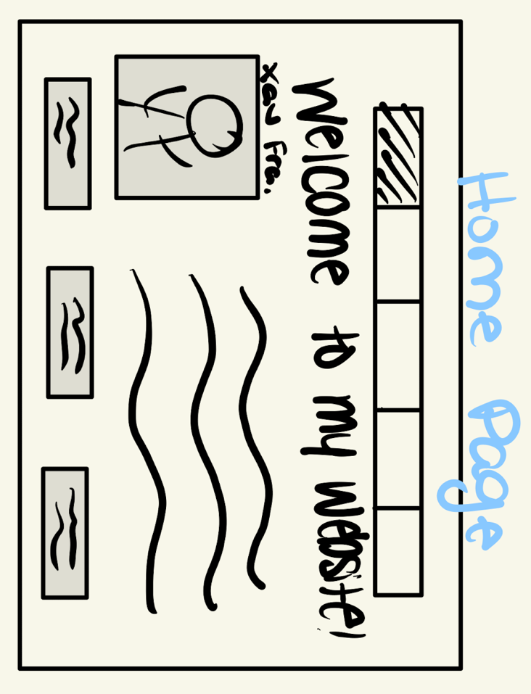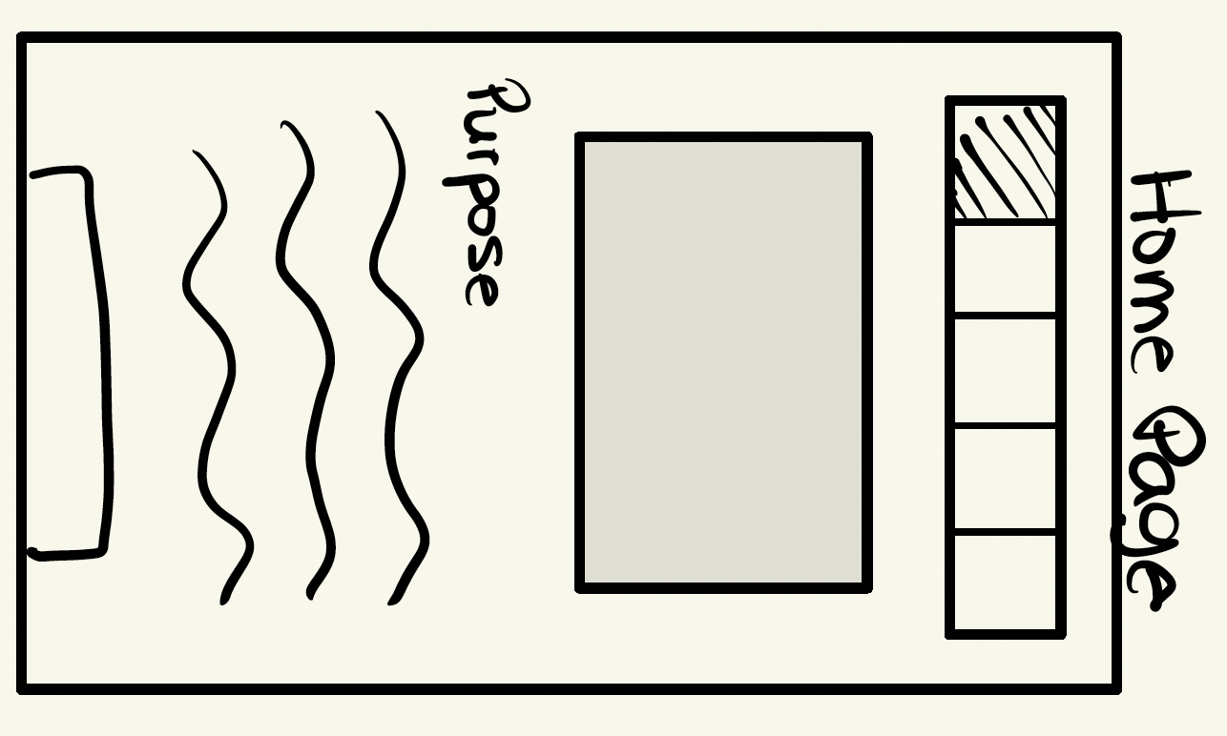
- Include the Hex Codes for all colors used in your website design
  - #CC9966 – Beige, #663300 – Brown, #000000 – Black, #FFCC99 – Light Orange, #FFFFFF – White
- Include the fonts you will use in your website
  - Bodoni, Times New Roman, Playfair Display
- Include the content inventory for the page (hint: this should be mostly in your Week 1 submission)
  - The purpose of this website is to highlight my experiences, goals, interests and plans for my career as an engineer. It will go into depth about what I have done up to this point in terms of both my academics and up-to-date work experience as well as what I hope to do in the long run five, ten, and twenty years from now.
  - Resume Link

About Me Page
- Copy an image of your wireframes (phone, tablet, and desktop) (note, these should be a little more filled out since you created them in Week 2)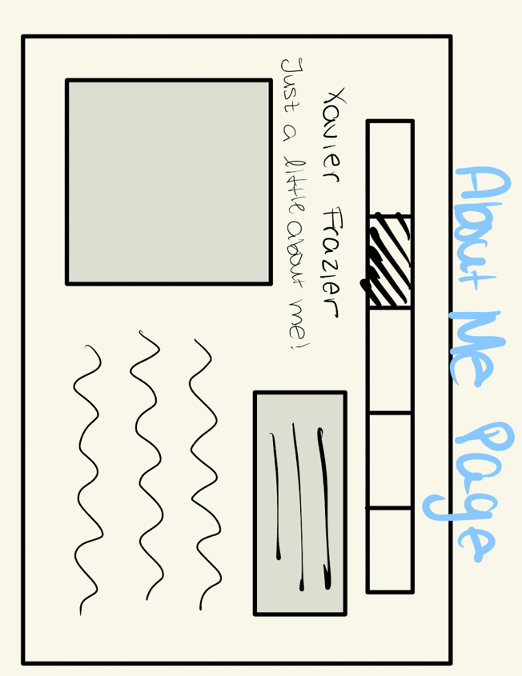
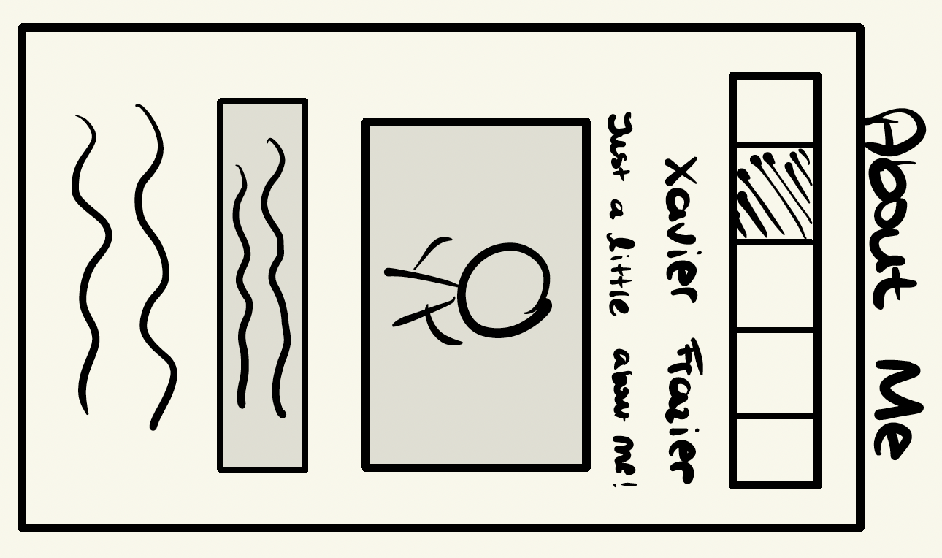

- Include the Hex Codes for all colors used in your website design
  - CC9966 – Beige, #663300 – Brown, #000000 – Black, #FFCC99 – Light Orange, #FFFFFF – White
- Include the fonts you will use in your website
  - Bodoni, Times New Roman, Playfair Display
- Include the content inventory for the page (hint: this should be mostly in your Week 1 submission)
  - My name is Xavier Frazier, and I am a Senior at the University of Missouri ~ Columbia. I am majoring in Electrical Engineering and minoring in Mathematics and Computer Science. My estimated completion date of my degree and minors is December of 2024. I hope to enter some kind of security or tech in engineering. I mainly hold major interests in cybersecurity, government defense and security, all kinds of tech, both hardware and software, web and coding development, wiring diagrams, and generally all kinds of problem solving within the engineering field. I have been exposed to mathematics and engineering essentially off my of life, which has played big role and a strong influence on my decisions through high school, college, and continually moving forward. I have dedicated my time in school, in addition to a few internships that I had to learn, apply what I have previously learned, polish skills that I feel that I already have.

Work Page
- Copy an image of your wireframes (phone, tablet, and desktop) (note, these should be a little more filled out since you created them in Week 2)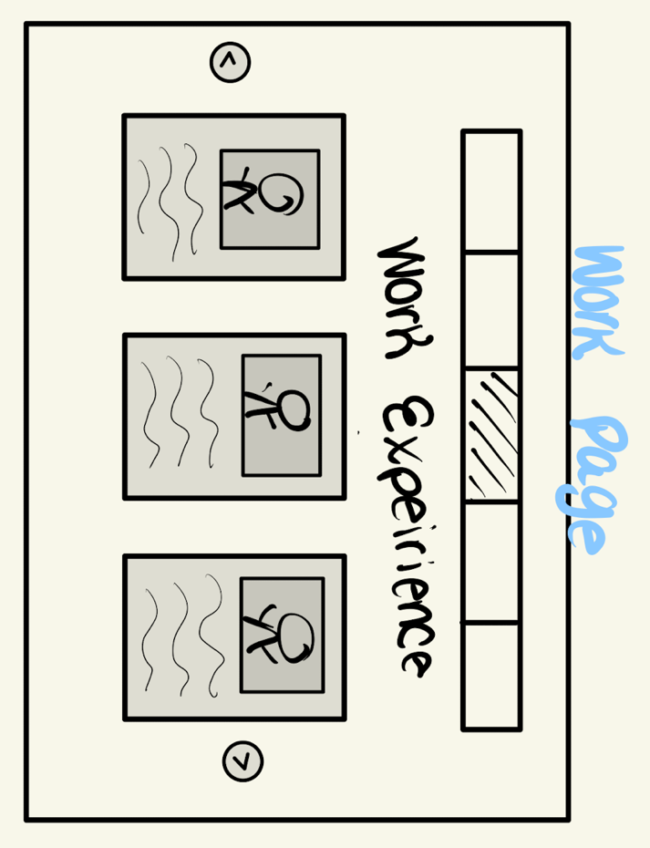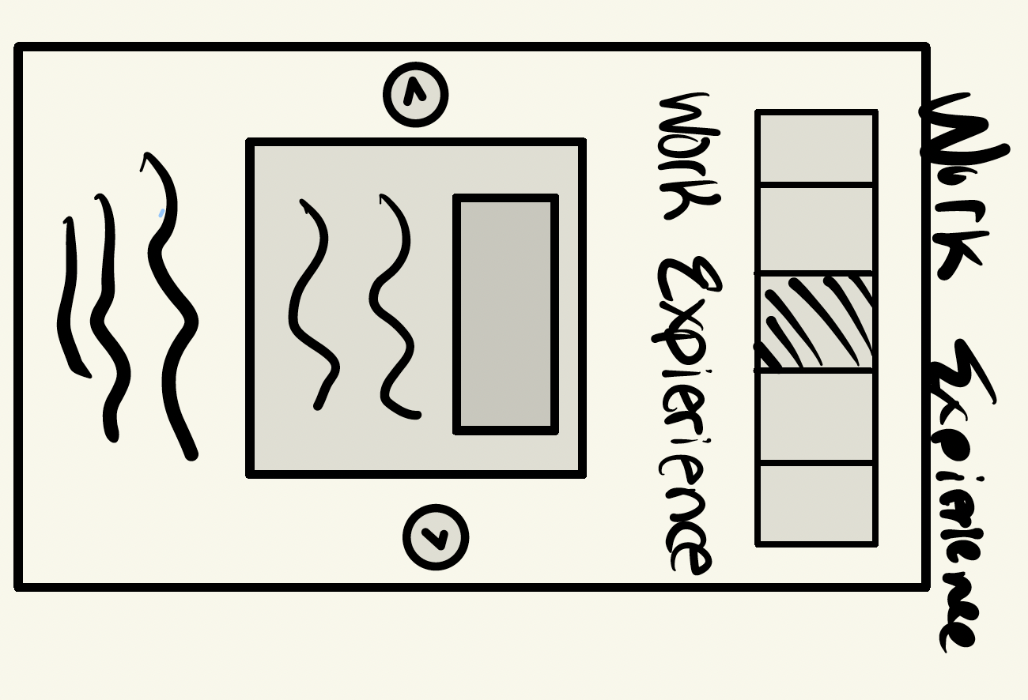
- Include the Hex Codes for all colors used in your website design
  - CC9966 – Beige, #663300 – Brown, #000000 – Black, #FFCC99 – Light Orange, #FFFFFF – White
- Include the fonts you will use in your website
  - Bodoni, Times New Roman, Playfair Display
- Include the content inventory for the page (hint: this should be mostly in your Week 1 submission)
  - The Boeing Company, Oklahoma City, OK - Internship (May 2023/24 – August 2023/24): Proactively acquired expertise in military standards for government aircraft requests, focusing on compliance and mission-critical requirements. Developed comprehensive Statements of Work (SOW) and thoroughly analyzed technical drawings, documentation, and wiring diagrams for AWACS aircraft. Provided crucial support in the Line Replaceable Unit (LRU) qualification process by coordinating testing protocols, ensuring adherence to regulatory guidelines, and facilitating the approval of devices integrated into aircraft used in global operations. Contributed to enhancing the reliability and mission-readiness of systems deployed in military aircraft for various international clients.
  - Commonwealth Edison (Exelon), Chicago, IL – Internship (May 2022 – August 2022): Developed a solid understanding of permit proposals, cross-sectional mapping, manhole designs, and the considerations between overhead and underground infrastructure, while gaining familiarity with industry-specific applications like TED. Modeled an underground fiber route spanning 26 miles, identifying the most cost-effective duct locations through detailed cost-benefit analysis. Simultaneously, deepened knowledge of transformers, fuses, and communication systems, along with their associated requirements, to enhance power distribution efficiency by up to 40%. This experience contributed to optimizing project planning, minimizing expenses, and improving overall network performance.
  - Wight & Company, Darien, IL – Internship (May 2019 – August 2019): Acquired hands-on experience in weekly preplanning and the continuous process of construction management, including coordinating with specialized subcontractors in areas like glass installation and concrete work. Actively participated in cross-functional meetings with partnering companies, gaining insights into crucial aspects of project execution such as safety regulations, site diversity, pricing strategies, workflow efficiency, and scheduling milestones. Developed a comprehensive understanding of collaboration dynamics, project timelines, and the critical balance between cost control and operational effectiveness in large-scale construction projects.
  - Disability Center – On Campus Employment, Columbia, MO (August 2022 – Present): Demonstrated inclusive respect and adaptability while supporting students from diverse backgrounds and with various disabilities, offering assistance with reading and writing tasks as needed. Exercised a high degree of professionalism by strictly adhering to FERPA guidelines, safeguarding student privacy, and maintaining confidentiality. Simultaneously, ensured academic integrity in all interactions, fostering a supportive and equitable learning environment tailored to individual needs.
  - First Year Engineering PLA/TA (January 2024 – Present): Served as a Teaching Assistant for an introductory engineering course at Mizzou, guiding first-year and transfer students as they transitioned into the engineering program. Provided academic support, clarified course concepts, and facilitated hands-on learning experiences designed to build a strong foundation across multiple engineering disciplines. Actively contributed to class management, assisted with grading, and offered mentoring to help students develop essential skills for their engineering journey, while fostering an engaging and inclusive classroom environment.

Reflection Page
- Copy an image of your wireframes (phone, tablet, and desktop) (note, these should be a little more filled out since you created them in Week 2)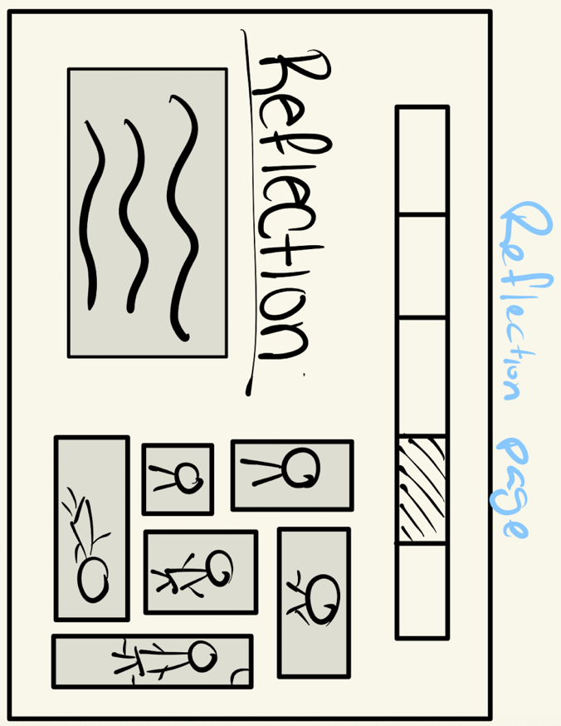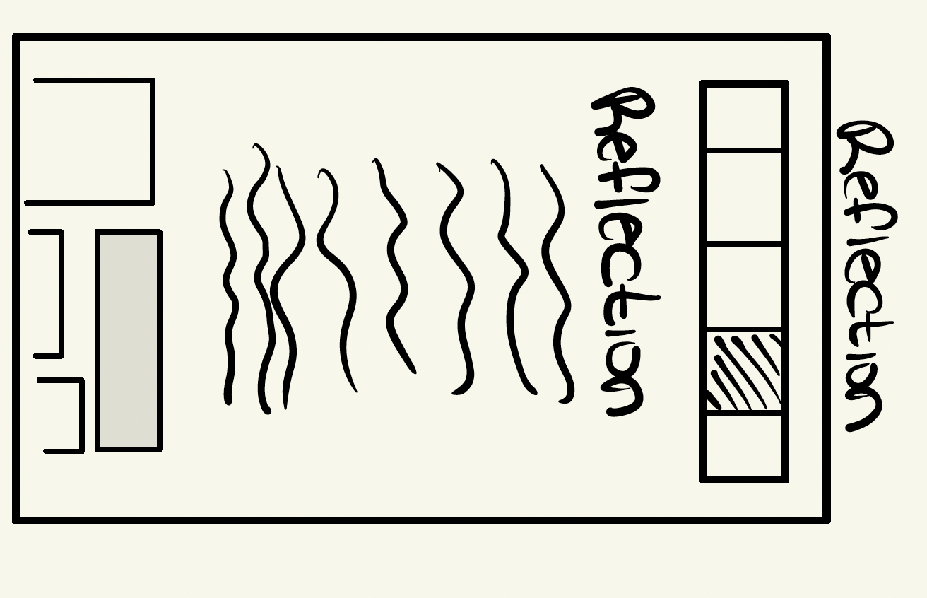
- Include the Hex Codes for all colors used in your website design
  - CC9966 – Beige, #663300 – Brown, #000000 – Black, #FFCC99 – Light Orange, #FFFFFF – White
- Include the fonts you will use in your website
  - Bodoni, Times New Roman, Playfair Display
- Include the content inventory for the page (hint: this should be mostly in your Week 1 submission)
  - My academic journey has been shaped by a deep-rooted passion for problem-solving, technology, and engineering. From an early age, my exposure to mathematics and engineering concepts significantly influenced my path through high school and into college. This foundation has driven me to explore various paths of engineering, ultimately sparking an interest in cybersecurity, defense, and security, as well as a wide range of technology applications. My goal is to transition into a career in the tech or security sectors, where I can continue to challenge myself and apply the skills I’ve developed throughout my academic and professional experiences.

Throughout my time in college, I’ve had the opportunity of engaging in internships that have not only strengthened my knowledge but also allowed me to apply classroom theories to real-world situations. At The Boeing Company, I gained expertise in military standards and aircraft compliance, particularly focusing on government defense projects. My role involved analyzing technical documentation, wiring diagrams, and supporting the qualification process for mission-critical devices in international aircraft. This experience helped my ability to work within regulatory standards while contributing to enhancing the operational reliability of global defense systems. Additionally, during my time at Commonwealth Edison (Exelon), I got into power distribution and infrastructure management. By modeling a 26-mile underground fiber route and conducting cost-benefit analyses, I learned the intricacies of optimizing both overhead and underground utilities. These opportunities solidified my passion for problem-solving and gave me a comprehensive understanding of various engineering domains.

In addition to my internships, I’ve gained valuable experience on campus through my work with the Disability Center and as a Teaching Assistant for the First-Year Engineering program. At the Disability Center, I developed a strong sense of responsibility and empathy, supporting students with diverse needs while strictly adhering to FERPA guidelines. My role required balancing confidentiality with the assurance of academic integrity, which helped me strengthen my communication and organizational skills. Meanwhile, as a Teaching Assistant, I have enjoyed mentoring first-year and transfer students as they embark on their engineering journey. By helping them navigate foundational concepts and coursework, I’ve been able to give back to the program that shaped my own early experiences while reinforcing my leadership and teaching abilities.

As I approach the final chapter of my undergraduate education, my career aspirations are becoming clearer. I envision myself working at the intersection of technology and security, whether that be within the realms of cybersecurity, government defense, or broader tech applications. My passion for both hardware and software, coupled with my interest in web development, coding, and technical problem-solving, drives my pursuit of a career where I can continuously learn and innovate. I am excited to leverage the technical knowledge and practical experience I’ve gained to contribute to cutting-edge projects that protect critical systems and improve technological efficiency on a global scale.

Contact Me Page
- Copy an image of your wireframes (phone, tablet, and desktop) (note, these should be a little more filled out since you created them in Week 2)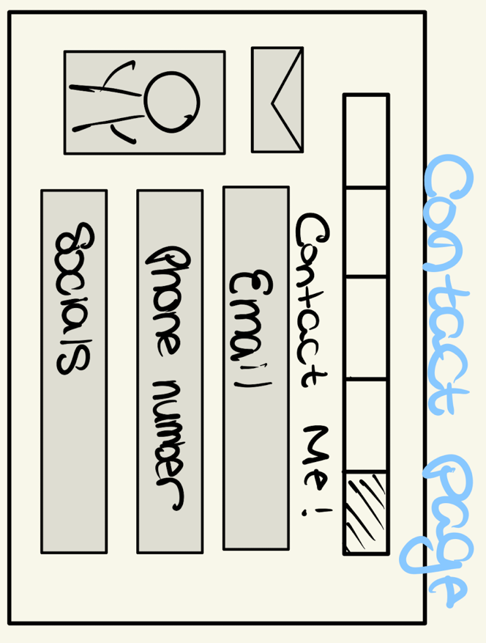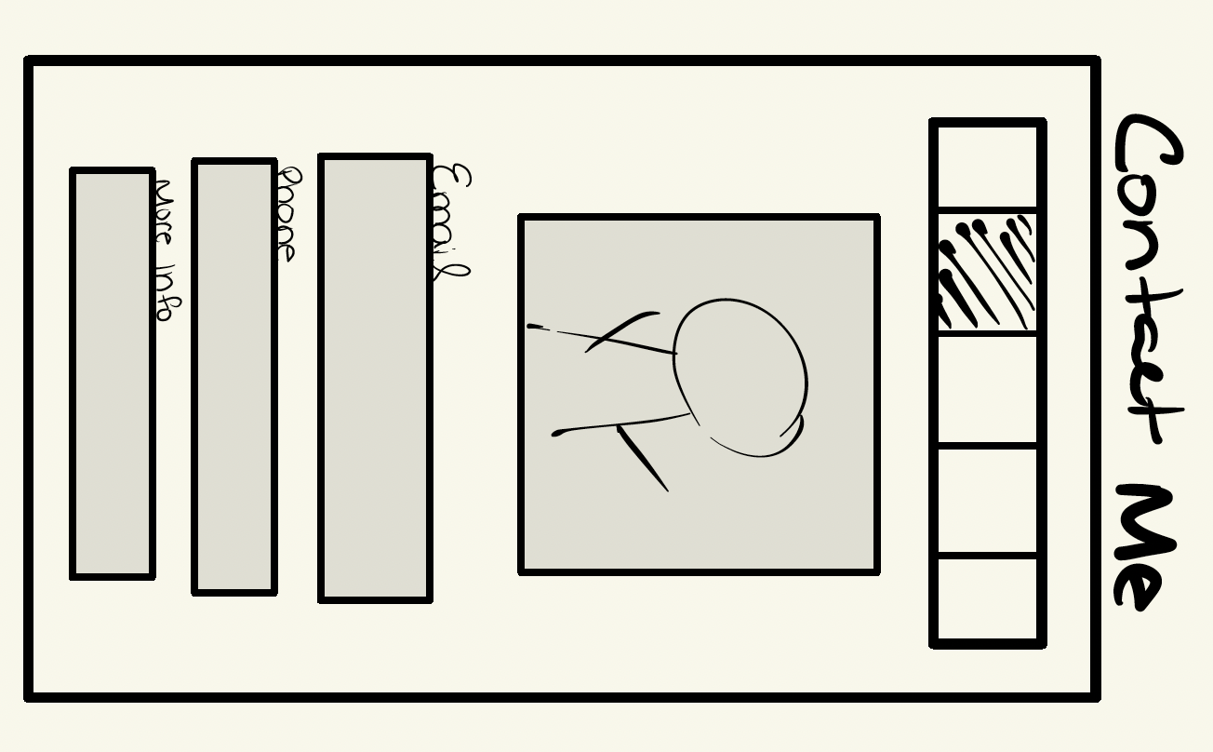
- Include the Hex Codes for all colors used in your website design
  - CC9966 – Beige, #663300 – Brown, #000000 – Black, #FFCC99 – Light Orange, #FFFFFF – White
- Include the fonts you will use in your website
  - Bodoni, Times New Roman, Playfair Display
- Include the content inventory for the page (hint: this should be mostly in your Week 1 submission)
  - Email: therealxavierfrazier@gmail.com
  - Phone: 708-513-5361

